Common Security Module and
User Provisioning Tool 4.5
Design Document
8/09/2012

[Type the abstract of the document here. The abstract is typically a short summary of the contents of the document. Type the abstract of the document here. The abstract is typically a short summary of the contents of the document.]

Contents
Document Change History 3
1. Purpose 3
2. Background 3
3. Functionality Analysis 4
4. Architecture 7
5. Implementation Consideration 8
5.1 Authorization Schema 9
Special PROTECTION_ELEMENTs 9
Special PROTECTION_GROUPS 10
User Defined PROTECTION_GROUP 11
5.2 User Provisioning CSM API 11
5.3 UPT Web Module 12
Step One: Create Control Records 13
Step Two: Configure UPT Operation 13
Step Three: Protect UPT operations 14
6. Migration Consideration 14
7. References 14
Appendix A. 15

Document Change History
Version | Date | Changed by | Description
1.0 | 06/12/2012 | Eugene Wang | Initial draft
1.01 | 06/20/2012 | Eugene Wang | Updated with comments from Prasad
1.02 | 7/13/2012 | Eugene Wang | Synchronized with implementation

Purpose
The purpose of this document is to provide design details for Common Security Module (CSM) and User Provisioning Tool (UPT) 4.5 version. The scope of this version addresses functional improvements as well as usability improvements.
Functional Improvements include:
- Configurable user provisioning operations
- User account activation.
- Encryption of Personally Identifiable Information (PII).
- NIH Password Policy enforcement.
- Configurable password management.
Usability Improvements include:
- Account lockout threshold setting
- Association navigation filtering
- Extensible UPT web application
Instead of providing design details for all features of 4.5 versions, this draft document focuses on Configurable User Provisioning Operations, other feature maybe added in later or described with separated document.

Background
The CBIIT Common Security Module (CSM) provides a comprehensive solution to common security objectives, with flexible delivery of security tools to allow application developers to integrate security with minimal coding effort. This helps eliminate the need for development teams to create their own security methodology. CSM provides solutions for authentication, authorization, and security provisioning.
Authentication
This process validates and verifies a user's credentials. CSM verifies user’s credential at application level with account name and password. It works with credential providers including Lightweight Directory Access Protocol (LDAP), Relational Database Management Systems (RDBMS) and others to confirm that a user exists and the password is valid for that application.

Authorization
This process determines what level of a particular authenticated user should have to access the secured resources. It depends on authentication systems to ensure that users are who they claim to be. CSM authorizes user’s privileges with Relational Database Management Systems (RDBMS) such as Oracle, MySql, or PostgreSql. It grants users permission to access secured data, perform desired operation, or navigate associated objects only if they have the required privilege.

User Provisioning
This process manages user’s identities and grants their authorization privileges. User identity management includes creation, maintenance, and deletion of user accounts. Current CSM only maintains active user accounts; it removes all user information once an account is deleted. CSM 4.5 will replace the “deletion” process with “de-activate/re-activate” process. If an account is deleted, CSM will not remove user information rather than de-activate it. The de-activated user account is maintained for either audition or re-activation later.

Privilege management includes consolidating users into groups, assigning an access right to user or group.

User Provisioning Tool
The CSM User Provisioning Tool (UPT) is light weight web-based application. It can be integrated with single or multiple applications and authorization databases. The UPT provides functionality to create, edit, and delete authorization data elements such as Roles, Privileges, Protection Elements, Users and Groups, and also provides functionality to associate them with each other. The runtime API can then use this authorization data to authorize user actions.
The UPT consists of following two operational modes:
- Super Admin - used by the UPT's overall administrator to register an application and assign administrators
- Admin - used by application administrators to modify authorization data, such as roles, privileges, and users

Functionality Analysis
Appendix A lists all features for release 4.5, but the following sections only focus on feature 4.5.1, Configurable User Provisioning Operations. For other features, their detailed information and design are available in related documents. They may be consolidated into one design document later.
User Provisioning Mode and Operations
User Provisioning Tool (UPT) defines two modes: Super Admin, Admin. Both modes have full scope of user provisioning capabilities except Super Admin mode provides additional capabilities such as registering application. For some applications, the two modes are defined as same with each other to simplify user’s roles.
The Admin Mode of the UPT is divided into six major "locations" or Home pages: Group, Privilege, Protection Group, Role, User, Instance level and Protection Element. In these locations, an Admin user can perform functions such as create, modify, or delete the elements, and manage or delete the associations between the elements.
The diagram below illustrates all elements (also sometimes referred to as objects) and their relationship with the Authorization Schema.
Figure 3.1.UPT Authorization Schema and Element Relationship
The Table 3.1 below provides definitions for each Authorization Schema element shown in the above diagram. The elements are listed by how they are associated, with the individual element defined and then the related group element defined.
Schema Element | Definitions for Authorization Status
User | A User is someone who requires access to your application. Users can become part of a Group, and can have an associated Protection Group and Roles.
Group | A Group is a collection of application users. By combining users into a Group, it becomes easier to manage their collective roles and access rights in your application.
Protection Element | A Protection Element is any entity (typically data) that has controlled access. This can be an object and/or its attributes. Examples include Social Security Number, City, and Salary.
Protection Group | A Protection Group is a collection of application Protection Elements. By combining Protection Elements into a Protection Group, it becomes easier to associate Users and Groups with rights to a particular data set. Examples include Address and Personal Information.
Privilege | A Privilege refers to any operation performed upon data. CSM makes use of a standard set of privileges. This will help standardize authorization to comply with JAAS and Authorization Policy and allow for adoption of technology such as SAML in the future.
Role | A Role is a collection of application Privileges. Examples include “Record Admin” and “Document Reviewer”.
Final Association | The final association is the correlation between a User or Group, and their assigned Roles for a particular Protection Group.
Table 3.1. Authorization Status Element Definitions
Configurable User Provisioning Operations
As shown in the above section, UPT Admin users are granted full scope of access permissions to all the six UPT locations (elements). They are able to perform all operations over these elements such as create, modify, delete, or setup association between these objects.
UPT is a standalone web application with security provisioning capabilities using CSM API. Any application can provide the same kind of user provisioning capabilities as UPT as long as it implements the same set of CSM API. For any application, there are two equivalent approaches to achieve the goal of UPT capabilities:
- Implement CSM API within its application
- Use UPT as supporting component to provide using provisioning capabilities.
Problems arise if an application adopts a mixture of the two above approaches since they use the same set of CSM API and share the same user provisioning database schema. For example, UPT provides capability to add and update a user into CSM RDBMS schema. If an application implementing CSM API, it would have same capability to add and update a user with in their application. Then, it would prefer to remove the same capability from default UPT but intact all the UPT capabilities. Because UPT packs all its operations together, it can never meet the requirements of this scenario, application has to develop those screens from scratch all again.
The proposed Configurable User Provisioning Operations will resolve these problems supporting customizable, extendable and flexible UI, web server actions, event handling mechanism. An application could include UPT web application components as a plug-in unit and use UPT functionalities. UPT will be modified to satisfy these requirements as following:
- Clean separation of business logic with presentation
- Ease the burden of developing and maintaining applications that run using UPT
- Ease of UI state management, event handling, input validation, page navigation and accessibility.
- Facilitate customizable branding with UPT pages
- Support customizable and extendable actions and user interface to include within an existing web application

Architecture
UPT is User Interface layer of CSM user provisioning API defined on the common user provisioning concept. The CSM user provisioning API is a subset of overall CSM API. It internally uses the CSM API's to perform user provisioning on the CSM Schema. UPT is a multi-tier web application implemented using Struts Frameworks MVC (Model-View-Controller) architecture. It leverages many technologies and frameworks including JSP, HTML, Struts, Spring, etc.
Figure 4.1 is the architecture diagram of a multi-tier UPT instance. It performs authorization using CSM schema deployed on a rational database server and performs authentication through the configured credential providers (LDAP or RDBMS). In this diagram, the credential provider is configured on a separated RMDB server, but it can be configured on the same RDBMS server with CSM schema.
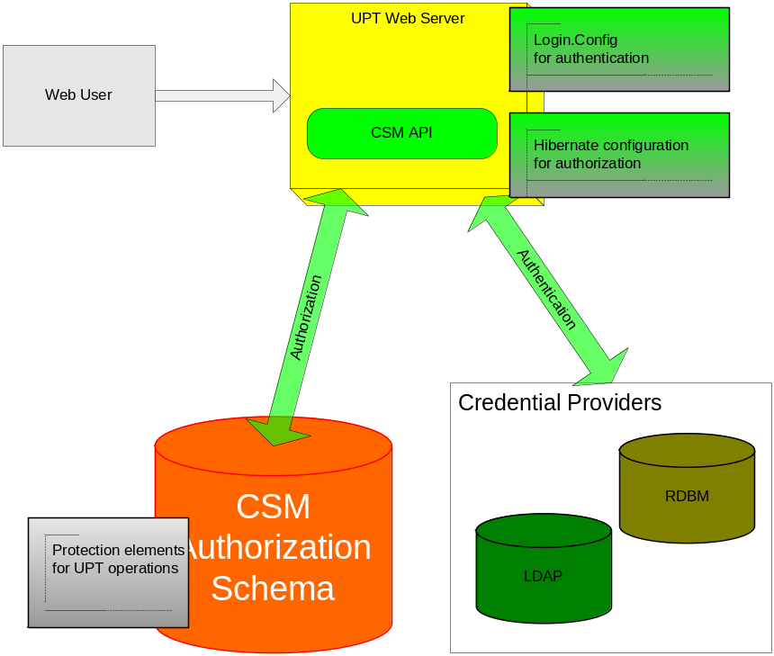
Figure 4.1 Architecture Diagram—Configurable UPT Operations
Configurable UPT operations are improvement features to authorize CSM Admin user performing UPT functionalities. These new features do not change authentication mechanism over any UPT deployment modes:
- Single installation, single schema
- Single installation, multiple schemas
- Local installation, local schema
These new features impact CSM authorization process in all tier/components, including:
- Authorization schema
- User Provisioning CSM API
- UPT web module

Implementation Consideration
This section details implementation approaches for the impacted tier/components for this release.

Authorization Schema
Authorization schema for UPT operations is part of CSM schema. It grants user access/execute permission based on CSM “protection” capability. This capability protects “elements”, “group of elements” of an application from accessing by its users. Following is the schema to support it:
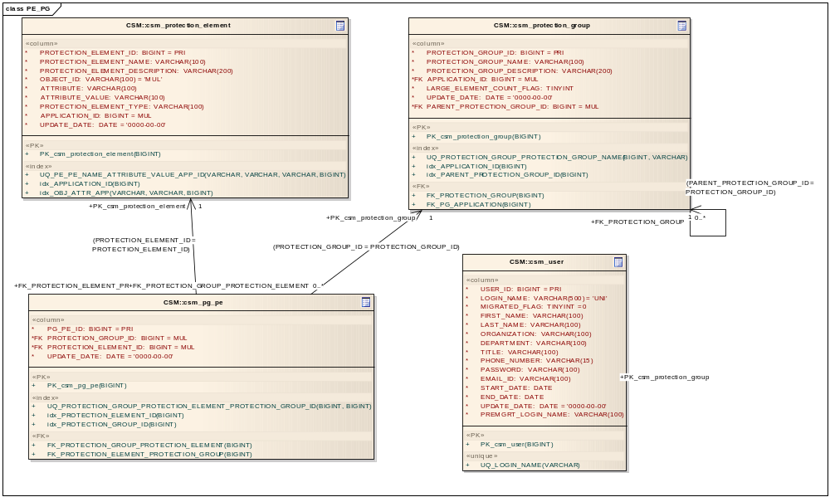
Figure 5.1 CSM Protection Schemas
As shown in Figure 5.1, there are various Protection Element objects and these objects can also be organized as various Protection Group objects. Based on roles and privileges, CSM API can grant user access permission to Protection Element or Protection Group.
The Configurable UPT Operation features leverage existing CSM authorization schema. It populates special records in table CSM_PROTECTION_ELEMNT and table CSM_PROTECTION_GROUP.

Special PROTECTION_ELEMENTs
Table 5.1 lists name/identifier and brief description of all these special CSM_PROTECTION_ELEMENT records. These records are unique within an application scope with predefined name/identifier to protect its designed UPT operation. They are created for an application as the application being registered to CSMUPT application. They are not editable for user.
Protection Element Name | Object ID | Protected UPT Operation | Operation Privilege | Note
Disable Flag for UPT:ACCESS_UPT_USER_OPERATION | ACCESS_UPT_USER_OPERATION | UPT_USER_OPERATION | CSM_ACCESS | Access/view CSM_USER
Disable Flag for UPT:CREATE_UPT_USER_OPERATION | ACCESS_UPT_USER_OPERATION | UPT_USER_OPERATION | CSM_CREATE | Create new CSM_USER
Disable Flag for UPT:UPDATE_UPT_USER_OPERATION | ACCESS_UPT_USER_OPERATION | UPT_USER_OPERATION | CSM_UPDATE | Update CSM_USER
Disable Flag for UPT:DELETE_UPT_USER_OPERATION | ACCESS_UPT_USER_OPERATION | UPT_USER_OPERATION | CSM_DELETE | Delete CSM_USER
Four more PROTECTION_ELEMENT records for UPT_PROTECTION_ELEMENT_OPERATION with privilege : CSM_ACCESS, CSM_CREATE, CSM_UPDATE, and CSM_DELETE
Four more PROTECTION_ELEMENT records for UPT_PRIVILEGE_OPERATION with privilege : CSM_ACCESS, CSM_CREATE, CSM_UPDATE, and CSM_DELETE
Four more PROTECTION_ELEMENT records for UPT_GROUP _OPERATION with privilege : CSM_ACCESS, CSM_CREATE, CSM_UPDATE, and CSM_DELETE
Four more PROTECTION_ELEMENT records for UPT_ PROTECTION _GROUP_OPERATION with privilege : CSM_ACCESS, CSM_CREATE, CSM_UPDATE, and CSM_DELETE
Four more PROTECTION_ELEMENT records for UPT_ROLE_OPERATION with privilege : CSM_ACCESS, CSM_CREATE, CSM_UPDATE, and CSM_DELETE
Four more PROTECTION_ELEMENT records for UPT_INSTANCE_LEVEL_OPERATION with privilege : CSM_ACCESS, CSM_CREATE, CSM_UPDATE, and CSM_DELETE
Table 5.1 Protection Elements for Configurable UPT Operations

Special PROTECTION_GROUPS
As it register a new application, system also creates two default records in table CSM_PROTECTION_GORUP.
- UPT Operation Protection Group for Admin Users– associated with all Disable Flags of UPT operation for admin users. As default, it is empty and admin user is able to perform all UPT operations.
- UPT Operation Protection Group for Application Users – associated with all Disable Flags of UPT operation for application users. As default, it is empty. An admin user can associate it with any PROTECTION_ELEMENT listed in table 5.1 to deny application user to perform any UPT operation.

User Defined PROTECTION_GROUP
In addition to the above two default PROTECTION_GROUP records, user can create any PROTECTION_GROUP as long as the user has privilege of CREATE_CSM_PRTOECTION_GROUP_OPERATION. The user defined PROTECTION_GROUP can hold one or more Disable Flags of UPT operations which are prohibited for specific user groups.

5.2 User Provisioning CSM API
The CSM AuthorizationManager interface provides all the authorization methods and services offered by the Common Security Module. It defines the operations which are required for the purpose of authorizing a user against the configured authorization data. It is the contract between any implementation classes and the Common Security Framework.
Configurable UPT Operation features require authoring user’s permissions to perform User Provisioning Operations. It would use checkPermissionForProvisioningOperationmethod in AuthorizationManager checking user’s permission to perform UPT operations. The following JavaDoc describes this method:
boolean checkPermissionForProvisioningOperation (java.lang.String operationName, java.lang.String userLoginName,
java.lang.String csmPrivilege, java.lang.String applicationContext) throws CSTransactionException
This method checks if a user is permissible to perform a User Provisioning Operation for a given application context. Names of the User Provisioning Operation are constants defined with gov.nih.nci.security.constants.Constants.
Parameters:
operationName – Name of User Provisioning Operation, which must be one of the following seven UPT operations:
CSM_USER_OPERATION
CSM_GROUP_OPERATION
CSM_PROTECTION_ELEMENT_OPERATION
CSM_ PROTECTION _GROUP_OPERATION
CSM_ROLE_OPERATION
CSM_PRIVILEGE_OPERATION
CSM_INSTANCE_LEVEL_OPERATION
csmPrivilege – name of CSM privilege, which must be one of the following values
CSM_ACCESS
CSM_CREATE
CSM_UPDATE
CSM_DELETE
userLoginName – CSM login name of user to perform a User Provisioning Operation
applicationContext - Name of the registered application
Returns:
true if the user is allowed to perform the desired User Provisioning Operation ; false if the user is denied
Throws:
CSTransactionException
See Also:
Constants

5.3 UPT Web Module
Figure 5.2 shows the menu bar section of
UPT home page has the UPT operation menu bar which contains seven UPT operation menu buttons. User can navigate all UPT operation screens by clicking enabled menu buttons. Current UPT grants admin users full access permission to all UPT operations, so all these menu buttons are active for admin user. Figure 5.2 is the UPT operation menu bar with all buttons being activated.
Figure 5.2. Full UPT Operation Menu Bar
The proposed Configurable UPT Operation features will limit user to access these UPT operations. CSM may grant or exclude user from one or one group of UPT operations. If a user is excluded to access a UPT operation, UPT will disable the corresponding menu button if that user login. Figure 5.3 shows Configurable UPT Operation Menu Bar with disabled “Role” and “Instance Level” operations.
Figure 5.3 Configurable UPT Operation Menu Bar
The proposed Configurable UPT Operation features do not required additional web page, but additional operation steps are required to implement it. As default SuperAdmin users register new application to CSM system and application admin users perform UPT operations. There are changes in two steps: create UPT Operation control records and enable configurable UPT operations.

Step One: Create Control Records
As described in section 5.1, system creates special control records as an application is registered. There are 42 PROTECTION_ELEMENTs and two default PROTECTON_GROUP records. User is optional to create more PROTECTION_GROUP records for configurable UPT operations.

Step Two: Configure UPT Operation
After the first step, all these PROTECTION_ELEMENT are independent from any PROTECTION_GROUP. Users, whoever has permission to perform UPT_PROTECTION_GROUP operations, can associate these special PROTECION_ELEMENT with any PROTECTION_GROUP to disable its corresponding UPT operation. Figure 5.5 shows that the flag Protection Element is associated with UPT_INSTANCE_LEVEL_OPERATION Protection Group, which disable “Instance Level” operation.
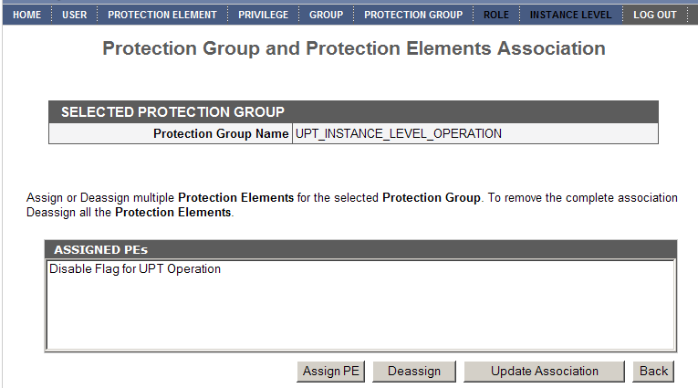
Figure 5.5. Association of Flag Protection Element with Protection Group

Step Three: Protect UPT operations
When user login, system checks user’s association permission to perform any of 42 predefined UPT operations. As default, SuperAdmin users have the privileges to access all UPT operations; application admin users or application users are granted a subset of the 42 predefined UPT operations.

Migration Consideration
The Configurable UPT Operation features require updates in both database and operation procedure. The database updates include creation flag Protection Element record and Protection Group records for all the UPT operations listed in table 5.1. CSM/UPT developer will prepare database update scripts for all supported database (oracle, mysql, postgreSql). For existing application, SuperAdmin users can create these special records from frontend with predefined names. The updated operation procedure requires application admin users configure UPT operations and grant permissions for application admin users to access one or more UPT operations.
The Configurable UPT Operation features are new for UPT extending functionalities of earlier versions. An application can ignore all these features by configuration operations. It an application does that users will not feel any impact of these features.

References
CSM 4.5 Scope Document, https://wiki.nci.nih.gov/display/caCORE/CSM+4.5+Scope+Document+-+DRAFT
CSM UPT 4.2.x User Guide, https://wiki.nci.nih.gov/display/caCORE/CSM+UPT+4.2.x+User+Guide
Appendix A. Maping between Release 4.5 Features and CSM/UPT Elements
The objective of the 4.5 version is functional improvements and usability improvements. These features will be implemented with minimum change of existing architecture and leveraging used technologies. This approach will benefit current CSM user with better backward compatibility and minor migration effort. Following table maps these features with existing CSM/UPT system elements.

Feature No. | Feature Name | Description | DB Schema Change | CSM API Change | UPT Change
4.5.1 | Configurable user provisioning operations | 1. Setup application level of control user’s access to user provisioning operations  2.Denny unauthorized user performing user provisioning operation | No | Yes,  1.Create protection element for each user provisioning operations  2.Only grant execute permission to authorized user | Yes,  Only enable web link/menu for authorized user
4.5.2 | User account activation | 1.Replace “delete” with “de-activate” user account function  2.Archive “de-activated” user’s account information  3.Re-activate a previously deactivated user account | Yes,  1.Additional column of user table to hold the status of user account  2.Current user with status of “active”  3.”Delete” user with status of “inactive” | Yes,  1. Modify “Delete” function to deactivate “active” user account  2. New API to activate “inactive” user account | Yes,  1.Display account status on user detail page  2.Add “account status” criteria to “Search User” operation  3. Add new operation to activate a user account
4.5.3 | Encryption of Personally Identifiable Information (PII). | Update CSM encrypt algorithm from DES to AES standard; AES has been effective as a Federal government standard on May 26, 2002. | No | Yes,  Additional APIs to encrypt and decrypt data to/from database | Yes,  UPT will use updated APIs
4.5.4 | NIH Password Policy enforcement. | Enforce NIH Password policy, http://datacenter.cit.nih.gov/interface/interface238/PW_policy.html | Yes,  - Record password age  - Archive password history | Yes,  1.Password validation  2.Password expiration | Yes,  1.Validate new password  2.Remind password expiration
4.5.6 | Configurable password management | Enable admin user to configure security policies | No,  Define security policy with configuration file | Yes,  1.validate password against security policy | Yes,  Apply UPT change with feature 4.5.6
4.5.7 | Account lockout threshold setting | Apply application level of control to user account lockout | No | No  The threshold is set with configuration file. | No
4.5.8 | Association navigation filtering | Current CSM only apply filter on searched object but ignore filter on the objects associated to the searched object | No | Yes,  Extend existing CSM to apply filter on the searched object as well as their associated objects | No,
4.5.9 | Extensible UPT web application | 1.support customizable and extendable actions and user interface 2.Include UPT within an existing web application | No | No | Yes,  1.Modularize UPT web components  2.Provide customizable deployment configuration  3.Setup extension framework

